Item Summary
Path : Reports >> Item Summary
Steps to reach Item Summary:
Step 1 : Reports in Steps to reach Item Summary : Open the Reports module from the Billing Application(POS).
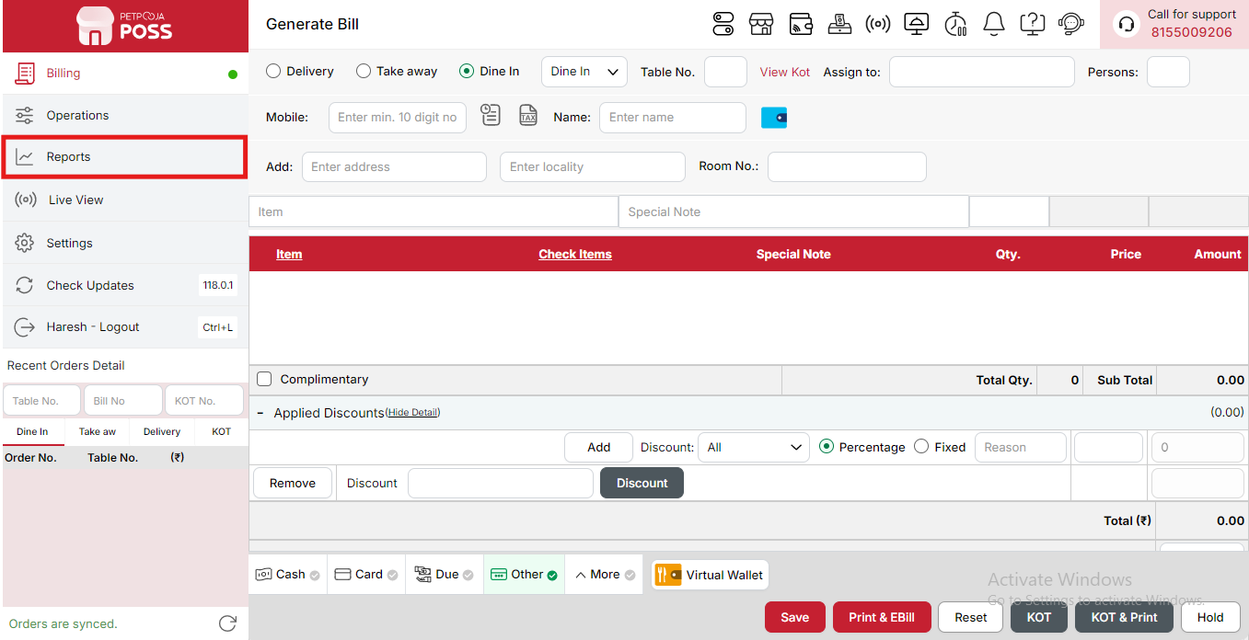
{Image Name: Reports Option,
Description: The red box highlights the “Reports” option in the sidebar menu. This section allows users to view and analyze various business reports, such as sales, billing, and order summaries, helping in effective tracking and decision-making.Here is an image of Step 1 Report in Steps to Reach Item Summary.}
Step 2 : Item Summary in Steps to reach Item Summary : Select Item Summary to view detailed sales and performance data for individual menu items, including quantity sold, revenue, and discounts applied.

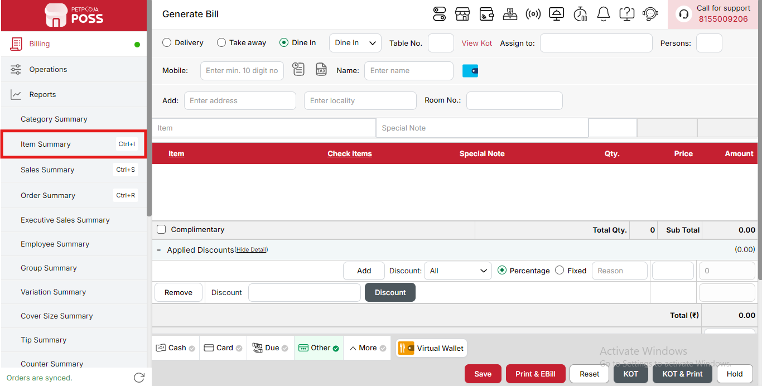
{Image Name: Item Summary Overview,
Description: This image highlights in the red box the Item Summary section, where you can view detailed reports of all sold items, including quantities, pricing, and discounts applied.Here is an image of Step 2 Item Summary in Steps to Reach Item Summary.}
Key features of Item Summary :
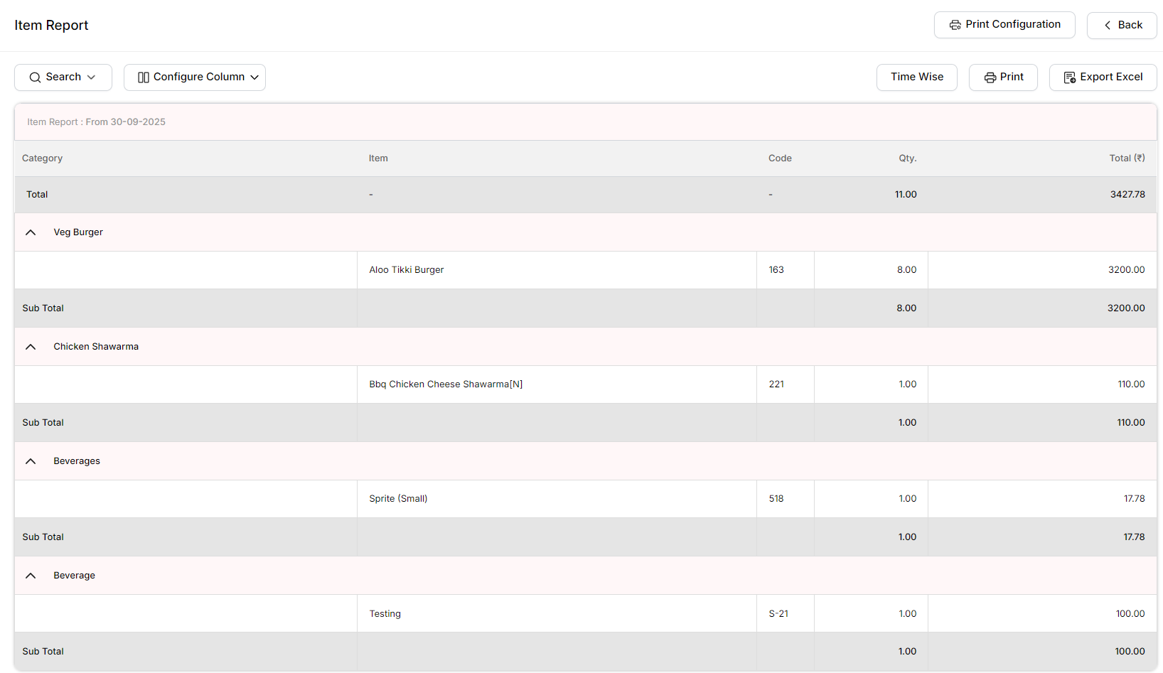
{Image Name: Item Report Overview,
Description: This image highlights in the red box the Item Report section, where you can view detailed reports of all sold items, including their category, item code, quantity, and total sales amount.}
- (Item Summary) Item Report: This report shows detailed information about each item sold, including the category, item name, code, quantity, and total amount. It helps you track which items are selling the most and analyze sales performance for each product.
- (Item Summary) Category: This column shows the name of the item’s category. For example, Veg Burger, Chicken Shawarma, Beverages, etc.
- (Item Summary) Item:This column displays the specific item name under each category. For example, Aloo Tikki Burger or Sprite (Small).
- (Item Summary) Code: This shows the unique code number for each item. It helps in identifying the item easily in the system.
- (Item Summary) Qty. Quantity: This shows how many units of that item were sold during the selected period.
- (Item Summary) Total (₹): This shows the total amount of sales for that item based on the quantity sold.
- (Item Summary) Sub Total: This line shows the total sales amount for each category before adding all categories together.
- (Item Summary) Total : This shows the overall total sales for all categories combined.
Search Button (Item Summary) : The Search button is used to find the report for a specific date or time. It helps you quickly see sales details for the selected period. After choosing the date or time, you can click on Search to view the report.
- From Date (Item Summary) : This option is used to select the starting date for the report. It means the report will begin from this date.
- To Date (Item Summary) : This option is used to select the ending date for the report. It means the report will show data up to this date.
- Order Status (Item Summary):The Order Status option allows you to filter reports based on the type or status of the orders. You can choose one of the following options to refine your search:
- (Order Status) All: Shows all orders, regardless of their status.
- (Order Status) Success: Displays only successfully completed orders.
- (Order Status) Cancelled: Shows orders that were cancelled.
- (Order Status) Complimentary: Displays orders given as complimentary (free of charge).
- (Order Status) Sales Return: Shows details of returned sales or refunded transactions.
- Time Wise Option (Item Summary) : The Time Wise Option is used when you want to see the report for a specific time period within a day. After turning it ON, you can choose both date and time — for example, from 10:00 AM to 5:00 PM — to see sales during that time. If you keep this option OFF (Without Time Wise Option), then the report will show the whole day’s data for the selected date range without filtering by time.
Configure Column (Item Summary): Used to show or hide different columns in the report by checking or unchecking the boxes. If you want to see that column in the report, you have to check it, and if you want to hide it, you have to uncheck it.
- (Item Summary) Item: Shows the name or description of the item sold. You can check this to display the item name in the report or uncheck it to hide it.
- (Item Summary) Code: Displays the unique code or SKU assigned to each item. You can check this to view the item code in the report or uncheck it to hide it.
- (Item Summary) QTY: Shows the total quantity of each item sold. You can check this option to see the quantity in the report or uncheck it to hide it.
- (Item Summary) Total (₹): Displays the total sales amount for each item after discounts and taxes. You can check this to include the total in the report or uncheck it to hide it.
(Item Summary) Export Excel: If you want to download or save the report in Excel format, you have to click on the Export Excel button. This will create an Excel file of the report that you can open and use in Microsoft Excel.
(Item Summary) Print Configuration: This section is used to set how your report will look when you print it. You can change the format, size, and what details to show on the printed page.
- (Print Configuration) Format Preference: Used to select the layout or design of the printed report.
- (Print Configuration) Show Bill Header: If you check this option, the header (top part with company or shop name) will appear on the print.
- (Print Configuration) Show Bill Footer: If you check this option, the footer (bottom part with notes or messages) will appear on the printed report.
- (Print Configuration) NONE: Select this option if you don’t want to apply any specific print format or layout. The report will print in the default basic format without additional formatting or sections.
- (Print Configuration) Display To Date on Print: If you check this option, the “To Date” of the report will be shown on the printed page.
- (Print Configuration) Display Time on Print: If you check this option, the time will be displayed on the print along with the date.
- (Print Configuration) Display Summary Box on Print: If you check this option, a summary box will appear at the end of the report showing total amounts and other summary details.
- (Print Configuration) Display Print Date & Time on Print: If you check this option, the date and time when the report was printed will appear on the print.
- (Print Configuration) Main Width: Used to set the width of the report on the printed page. For example, 500 means the report will be printed with that width size.
- (Print Configuration) Font Size: Used to set the text size of the printed report. You can increase or decrease it as needed.
- (Print Configuration) Cancel: Click this button to close the print configuration window without saving any changes.
- (Print Configuration) Save:Click this button to save all the changes you made in the print configuration settings.

